BUSINESS DESIGN PROPOSAL
PENERJEMAH : TRANSLATION SERVICE
This paper was created to fulfill the task of Business and Design For English Course



Lecturer : Agci Hikmawati

Created by :
Alvin Setiawan ( 210441073 )

ENGLISH EDUCATION DEPARTMENT
FACULTY OF TEACHER TRAINING AND EDUCATON
MUHAMMADIYAH UNIVERSITY BANGKA BELITUNG
2023

- PROJECT TITLE: PENERJEMAH : Translation Service

- INTRODUCTION
Generally, translation is a process of rendering meaning, ideas, or messages of a text from one language to other language. There are some considerations which follow this process, which mainly related to the accuracy, clarity and naturalness of the meaning, ideas, or messages of the translation. It means that it is an important thing to consider whether the readers of the target text accept equivalent information as the readers of the source text do. In this era, where globalization takes place, the need to translate a paper or work is still high. With the help of technology the translation service evolve into something that is easy to do, but hard to master. The elements of human touch is still needed in translation. Simply because there are some aspect, such as cultural and sarcastic, that can’t be translated literally. Thus, the purpose of this report is to inform you about the production, development and business plan of TERJEMAHAN : Translation Service. It will give you guidance about our on-going project and how we construct it.

- PROJECT OBJECTIVES
- Help to translate the work of anyone
- Translate the paper to the mother language so it become more understandable.
- Translate the paper, so it can be recognized internationally.

- PROJECT DESIGNING
- Spread the Words
There are a few promotions that I will be doing, the first one is distributing flyers. Flyers will be distributed on social media through Instagram and whatsapp, but my main method to spread the word is by talking directly to the people. I will talk to some of my friends and family so that from some of my friends or family, I get other customers.

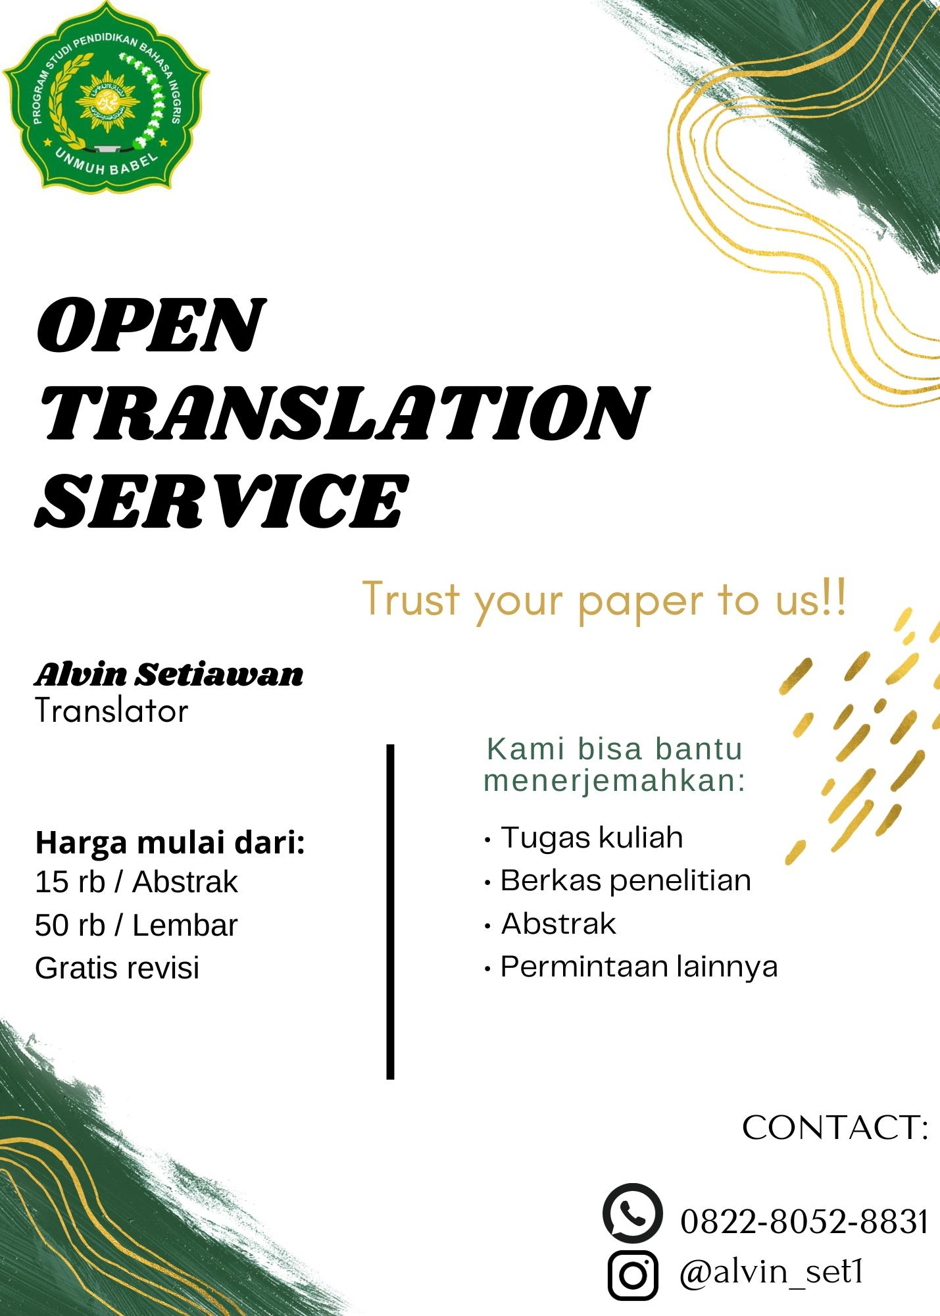

- Meet the Client
We will try to find some clients, and talk about the detail of his needs. There, we can talk about the time of the work and the price for it. After a deal, we will go down to work it, and finally deliver the final product.

- Who received my translation services and English Tutoring:
- Fitri
- Nurul
- Yoga
- Fikram
- Perabu
- Jian

- Project Implementation

In this case, with the translation services that I provide, I try to help those who have difficulty translating their assignments, as is the case with assignment services, the two are interrelated. For tutoring classes, I only teach reading, speaking and basic grammar to children and I also invite them to watch Disney videos in English.

- Project monitoring

For English lessons, I immediately met my two students at their homes directly in West Mendo.
And for translation services and assignment services, I communicate via telephone and provide the results of my work via telephone within one week.

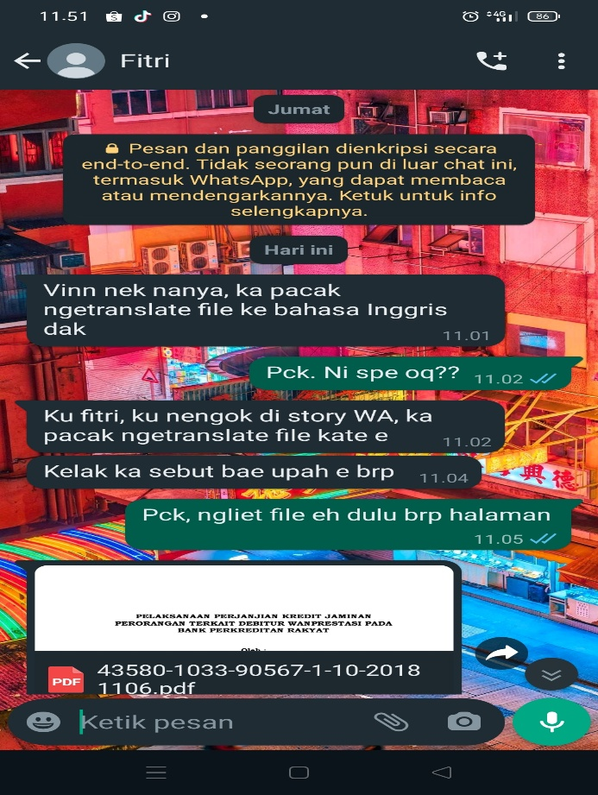
- Project documentation
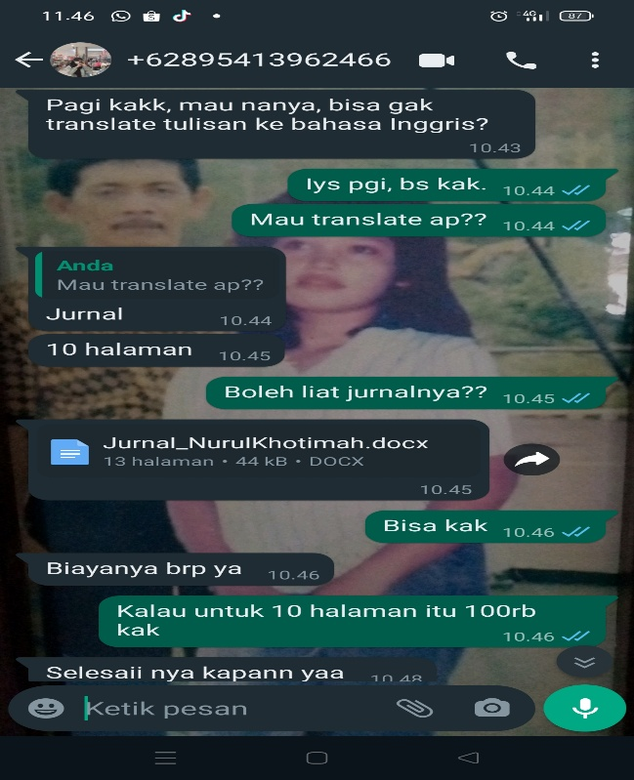
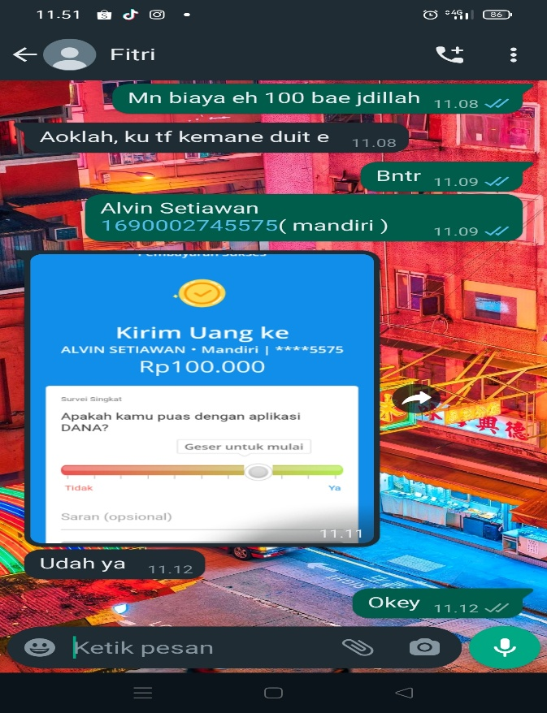
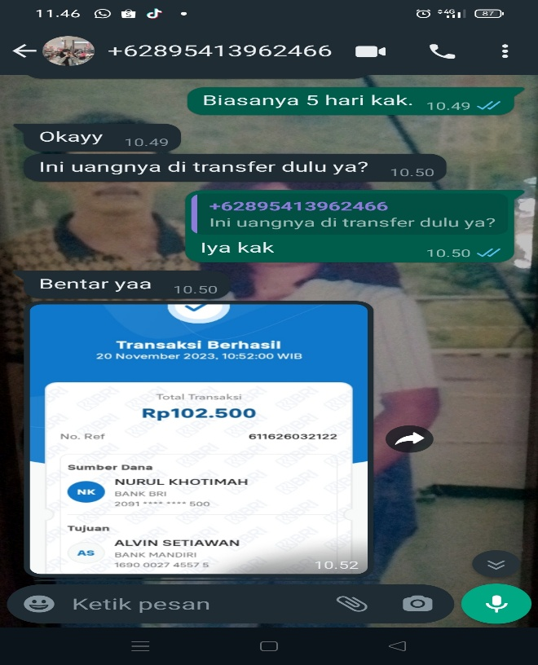
- Income

Translation services 3 people
Assignment service 1 people
English Tutoring 2 student

Translation services 10 halaman = 100k
45 halaman = 400k

Assignment service = 50k

English Tutoring = 1 month = 200k

400+50+200= 650k

